

निदेशक का कार्ाालर् / Office of the Director
कार्ाालर् आदेश / Office Order

संख्या/No. IISERBPR/DO/OO/2023/105 | दिनांक/Date. Sep 21, 2023

विषर्/Subject: Revised Leave Entitlement of Faculty of IISER Berhampur

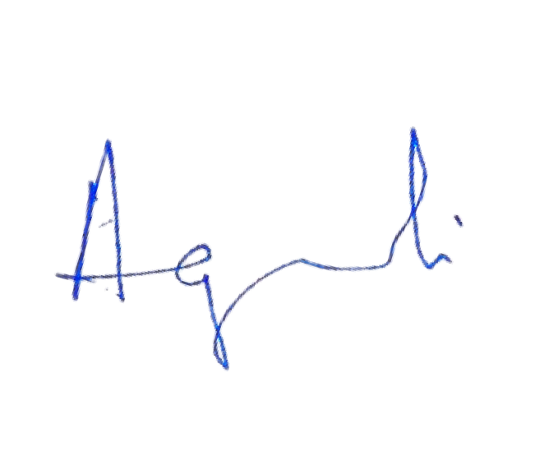In supersession of orders, all earlier instructions on this matter, a revised “Leave Rules for Faculty” is hereby enclosed to be applicable to all faculty members with immediate effect.

निदेशक/Director

दितरण/Distribution:
- All Faculty Members

- All Deans/HoDs/FICs
- Webmaster



Transit Campus: IISER Berhampur, Govt. ITI Premises, Engg. School Road, NH-59, Berhampur – 760010, District- Ganjam, Odisha
E-mail: director@iiserbpr.ac.in / directoroffice@iiserbpr.ac.in, www.iiserbpr.ac.in ; Telephone: 0680 222 77701



Indian Institute of Science Education and Research Berhampur Leave Rules for Faculty Members

 | Sl.  No. | Type of  Leave | Duration | Purpose | Remarks
 | 1. | Casual Leave (CL) | Maximum 8 days in a Calendar year | Personal reasons | - Should not normally be granted for more than 5 days at any one time, except under special circumstances.  - Can be combined with SCL/Vacation not with any other kind of leave.  - Weekly offs/Public holidays/RH can be prefixed/suffixed and Weekly off/Public holidays falling during the period of CL are not counted as CL. It can be  taken as half day also. LTC can be availed during CL.
 | 2. | Special casual Leave (SCL) | Maximum 30 days in a calendar year (maximum 15 days of SCL during one Semester) | Granted to a faculty member for academic/administrative purposes such as participation in conferences, undertaking examinership/thesis evaluation in academic institutions, attending selection committee meetings and national committee meetings, etc. This leave is primarily meant for professional (teaching, research,  discussion meetings, symposia, etc.,) including visit in connection with consultancy & sponsored research activities. | - Can be availed on a full-day basis  - Lapse at the end of the calendar year  - Can be taken at any time during the year irrespective of academic session.  - Any other condition as laid down by the Competent Authority.
 |  |  |  | Any other activities/purposes for which SCL is admissible as per GoI instructions.
 | 3. | On duty (Duty Leave) | As per the requirement. | Any assignments (administrative, academic/financial etc.) as given by the Institute such as IAT, MoE work etc. | The assignment(s) is/are to be approved by the Competent Authority of the Institute.
 | 4. | Vacation Leave | 60 in days in an academic year | As per the Institute policy | To be regulated as per the decision of the Institute and applicable provision of the CCS (Leave) Rules.
Rule-28(2) of the CCS (Leave) Rules: -Vacation may be taken in combination with or in continuation of any kind of leave under these rules: Provided that the total duration of vacation and earned leave taken in conjunction, whether the earned leave is taken in combination with or in continuation of other leave or not, shall not exceed the amount of earned leave due and admissible
to the Government at a time under Rule 26 of the CCS (Leave) Rule.
Page 1 of 3

 | Sl.  No. | Type of  Leave | Duration | Purpose | Remarks
 | 5. | Earned Leave | 5+5 days (five days of EL will be credited at the leave account in advance as on 1st January & 1st July every year) | Personal reasons | The leave account of every Government servant (other than a military officer) who is serving in a Vacation Department shall be credited with earned leave, in advance in two instalments of five days each on the first day of January and July of every calendar year (DOPT Notification. No. 11020/01/2017- Estt. (L),  dated 11.12.2018) and to be regulated as per the provision of  the CCS (Leave) Rules as amended from time to time.
 | 6. | Extra- ordinary Leave (EOL) | Upto 3  months to 24 months as per the length of services & other conditions as provided under CCS (Leave) Rules. | When no other leave is admissible or when other leave is admissible, but the faculty member applies in writing  for extraordinary leave | No pay & admissible allowances will be paid during the period of EOL. The period of EOL without medical certificate will not count for increment and other matters as provided under the Rules.
 | 7. | Maternity Leave | 180 days to female faculty members with less than two surviving children.  For miscarriage/ abortion: Total 45 days in the entire  service. | Maternity/Miscarriage/Abortion | To be regulated as per the applicable provision of the CCS (Leave) Rules as amended from time to time.
 | 8. | Paternity Leave | 15 days to Male faculty with less than two surviving children. | During the confinement of his wife for childbirth, i.e. up to 15 days before or up to six months from the date of delivery of the child or for child adoption (within a period of six months from the date of valid adoption). | If not availed of within the period specified, such leave shall be treated as lapsed & To be regulated as per the applicable provision of the CCS (Leave) rules as amended from time to time.
 | 9. | Child Adoption Leave | 180 days for female faculty members | Valid adoption of a child below the age of one year. | To be regulated as per the applicable provision of the CCS (Leave) rules as amended from time to time.
 | 10. | Child Care Leave | Maximum 730 days during the entire service for  women | For taking care of up to two eldest surviving children, whether for rearing or to look after any of their needs like examination, sickness, etc. | It shall not be granted for more than three spells in a calendar year; in case of a single female Government servant, the grant of leave in three spells in a calendar  year shall be extended to six spells
Page 2 of 3

Sl.  No. | Type of  Leave | Duration | Purpose | Remarks
 |  | faculty |  | in a calendar year. It shall not
 |  | member and |  | ordinarily be granted during the
 |  | single male |  | probation period except in case of
 |  | faculty |  | certain extreme situations where
 |  | members |  | the leave sanctioning authority is
 |  | having minor |  | satisfied about the need of child
 |  | children (no |  | care leave to the probationer,
 |  | age in r/o a |  | provided that the period for which
 |  | child with a |  | such leave is sanctioned is
 |  | minimum |  | minimal. Child care leave may not
 |  | disability of |  | be granted for a period less than
 |  | 40%) |  | five days at a time. During the
 |  |  |  | period of child care leave, a female
 |  |  |  | Government servant and a single
 |  |  |  | male Government servant shall be
 |  |  |  | paid one hundred percent of the
 |  |  |  | salary for the first three hundred
 |  |  |  | and sixty-five days, and at eighty
 |  |  |  | percent of the salary for the next
 |  |  |  | three hundred and sixty-five days.
 |  |  |  | Single Male Government Servant’
 |  |  |  | means – an unmarried or widower
 |  |  |  | or divorcee Government servant
 |  |  |  | and other conditions as applicable
 |  |  |  | under CCS (Leave) Rules.
11. | Sabbatical | Up to one | Research work, writing text | Academic staff is eligible after the
 | Leave | year at a | books, & visiting industrial | completion of 6 years of
 |  | time | concerns of Govt. University, | continuous regular service. The
 |  | including | Industry or Govt. research | staff has to furnish a bond to serve
 |  | vacation | laboratories in India/Abroad. | the Institute for 3 years on return
 |  |  |  | to duty.

Availing of all the above leaves by faculty members will be subject to the compliance of the applicable provision of the CCS (Leave) Rules/ Govt. of India Instructions/ Decision of the Competent Authority.

General Conditions:

  - Leave cannot be claimed as a matter of right.
  - Leave should always be applied for and sanctioned before it is taken, except in cases of exceptional situations and for satisfactory reasons.
  - Absence from duty after expiry of the granted leave entails disciplinary action as per the First Statutes of IISER treating it as a misconduct under code of conduct (CCS (Conduct) Rules).
  - Absence without prior sanction of leave/ unauthorised absence from duties will constitute a break in service and other action as per the Rules.
  - A faculty member on leave should not take up any service or employment elsewhere without prior sanction of the competent authority.
  - While applying for leave of any kind, the faculty member shall ensure that his academic/ administrative assignments are attended to by another faculty during his absence period, therefore the name of the faculty and his confirmation should be mentioned while submitting application for leave of any kind

Page 3 of 3

